Dear **Nagesh Survase**,

We want to say **Thank you** for entrusting Tvam!

Here is your report !

We are committed to providing you honest & **customized Vedic Astrology** solutions.

Before your read your analysis – We want to share the highlights in your chart – You can check your chart below.

The key **positive** area in this chart is **very strong Saturn**

The key **negative** area in this chart is **Venus in 8th house**

We hope that you will take the feedback in a positive way.

Regards

Team Tvam

Horoscope & Dasha

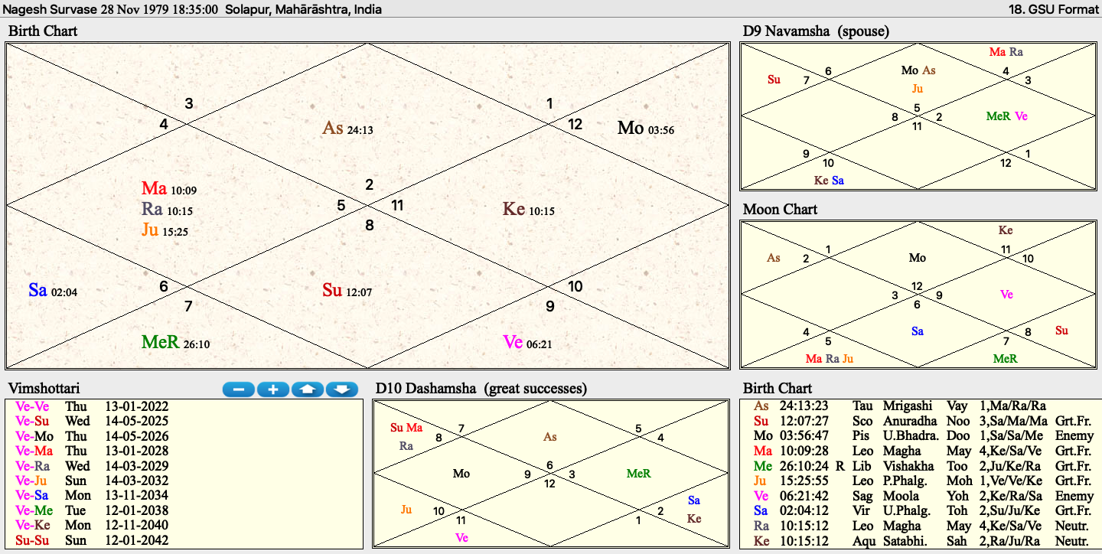

Key points related to your Financial life

* 11th lord is Jupiter and is posited in 4th quadrant house
* 2nd house lord is mercury, which is posited in 6th house
* Venus in 8th house of sorrows
* Currently venus major period going on
* Guru chandal yoga
* Sade Sati running currently
* Very powerful Mars Sun exchange

Key Yoga related to your Financial life

**Sankhya Dama yoga**

Wealth and prosperity

**Parvata Yoga**

Great wealth creation in this life

**Pamara Yoga**

Tendency to waste wealth/money in unnecessary things in life

**Raj Yoga**

Great rise in this life

**Vipreet Raj Yoga**

Sudden gains

**Dhan Yoga**

Great wealth creation in this life

**Arishtha Yoga**

Lot of wealth will be lost in health issues in family

Financial Life – General Reading

Ans:

* The current period is favorable as you are going through major period of your lagnesh Venus
* Having said that, Venus in 8th house, so it limits your prosperity
* Venus forming Vipreet Raj Yoga and can get you lot of wealth
* This current period is powerful and can change your fortunes till 2025
* You should invest in stock market
* Sudden gains are highly foreseen , especially after Oct 2024
* 4th house has Rahu+Mars+Jupiter and hence you should be very careful in property matters
* You should consider investment in stock market, rather than real estate as in long term you will do very well in stock market
* You should avoid real estate investments in 2024 as you might repent your decisions later on
* You should be very careful in legal matters when buying/selling properties
* Avoid buying properties in join names
* Since Venus in 8th house, your financial life will be limited and hence you will get less than what you deserve
* Since your sade sati is running,you can experience certain hurdles in life. But Saturn is very strong in your chart and hence your issues will be limited
* Exchange of 7th lord and 4th lord(Mars and Sun): Great wealth will be created in business
* Success in politics too or in a public profile
* Period till 2042 (Venus) is superb and will take you to new heights

Remedies for better financial life

* Wear White Sapphire
* Wear Blue Sapphire
* Listen to Shukra Gayatri Mantra
* Wear more white colors

**Qn. - In depth analysis regarding wealth accumulation, Laxmi Yogas, prosperity and abundance, favourable sources of income and investments as per my chart. - We are planning to buy two properties for renting purpose, please guide what type of property is favourable for us - residential flat/shop.And when we will be able to buy this property? - Please comment on my basic overall financial status/money flow throughout life. Will i be having good quality life?**

Ans.

* We have listed Yoga in a separate section above
* Financial life will be good , especially in the current venus major period
* Till 2025 its golden period
* We advise stock market investments
* We advise caution in real estate investments , especially in 2024

**Happy to help you Vedic way!**

**Team Tvam**