Dear Roberto,

We want to say Thank you for entrusting Tvam!

Here is your report !

We are committed to providing you honest & customized Vedic Astrology solutions.

Before your read your analysis – We want to share the highlights in your chart – You can check your chart below.

The key positive area in your chart is Very Strong Saturn

The key negative area in your chart is Debilitated Mars

We hope that you will take the feedback in a positive way.

Regards
Team Tvam

Kundli & Dasha

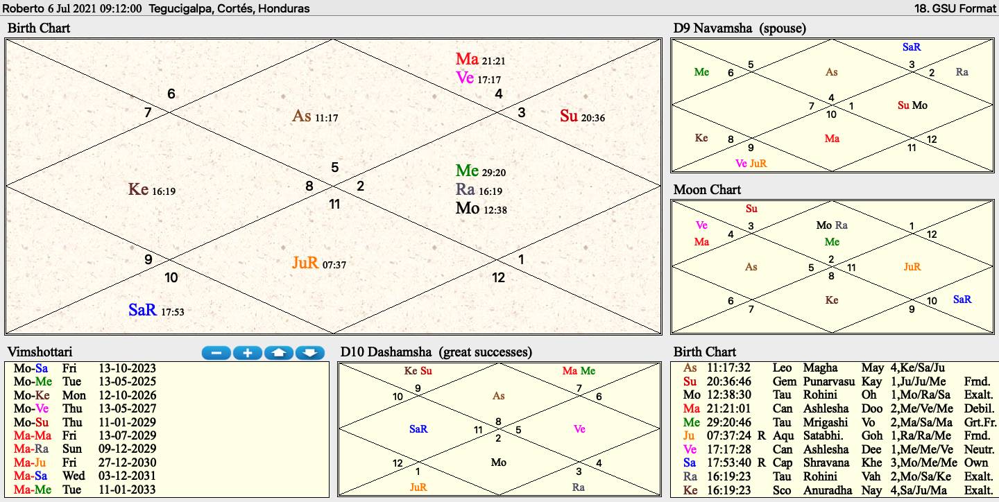

Q&A
Qn: I would like to know about the health of my 2.5 year old son (communication and relationship) and also have an idea about the professional interests he will have in his life (born at 9:12 am, July 6, 2021; Tegucigalpa, Honduras).
Now in those times where the media network bomb us with ADD, ADHD or Autism cases; all that warns us a little bit.
Regarding what is related to his 10th house, I would like to know what type of professional careers will interest him, in order to be able to develop the required areas and skills from an early age.
He said several complex words very early in his first few months, but since we moved a 1.5 ago to current apartment we rent, we feel like he has stop talking (WC in NNO direction, WC in NE and Kitchen in North direction between them). Regards
And not only, he has stop saying words since we moved to the current apartment, but he has stopped saying words.
In case you recommend me remedies at specific times or places, I have learned the basics of Jogannatha Hora (transits, ashtakarga, dasas) and also the basics of astrovastu (locating planets of Rasi, Dasa - antardasha in my apartment). Best regards

Ans:
Key Astrological consideration regarding the query :

- Exalted Moon + Rahu grahan in 10th house
- Debilitated Yogakaraka Mars
- Mars in 12th house
- Super strong Saturn in 6th upachaya in own zodiac
- 1st lord in 11th house of gains
- Mercury in 10th house
- Jupiter in 7th house
- Ketu in 4th house of domestic life
- Curently Moon major period running till July 2029
- Pitra Dosha

Predictions:

- A good chart wherein you should not bother at all
- Health is a cause of concern as mars is debilitated, but the lagnesh in 11th house of gain will ensure that all issues are fought bravely and do not have long term implications
- Having said that, prone to blood related ailments
- Exalted Moon and amplifier rahu in 10th house, so anything related to mind/thoughts will suit him lot as a professional like writing, creativity, arts etc
- You should not worry as its exceptional chart with strong Moon, Saturn and Sun
- Ketu in 4th house of domestic setup might create issues at home (in general) but there is nothing to worry
- Upcoming 7 yearlong Mars major period (starting July 2029) might not be good for health and hence utmost caution should be taken
Remedies:
- Live near water bodies
- Listen to Chandra Gayatri mantra in the current moon major period (dasa of 12th lord )
- Wear more white cloths
- Pray Lord Sun (your lagnesh or 1st lord)
- Visit religious places on Sundays
- Listen to Om chants or do Om chants if possible
- Avoid milk products as much as possible

Happy to help you Vedic way!
Team Tvam

