Namaste,

We want to say Thank you for entrusting Tvam!

Our Apologies for delayed report.

We are committed to providing you honest & customized Vedic Astrology solutions.

Before your read your analysis – We want to share the highlights in your chart – You can check your chart below.

The key positive area in your chart is Very strong Mercury (Wealth/Luck)

The key negative area in your chart is Combust Moon (Overthinking)

We hope that you will take the feedback in a positive way.

Regards
Team Tvam

Horoscope

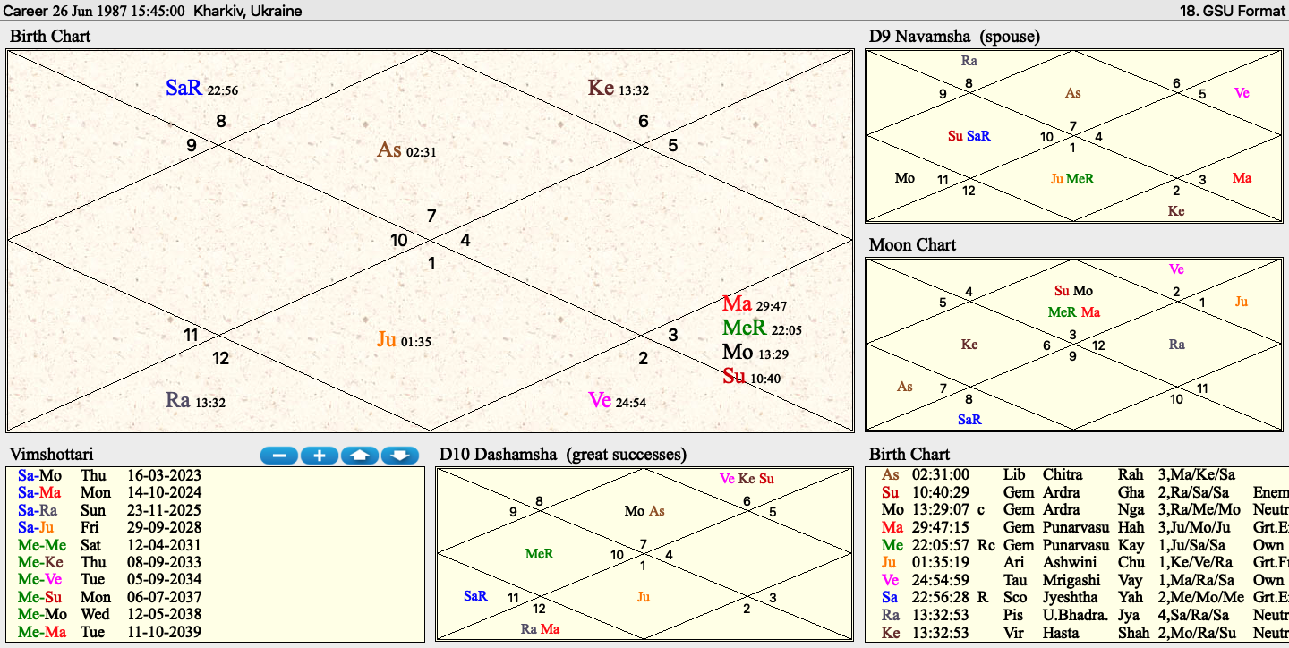

Career : Key points in your horoscope
- These are some astrological points which are relevant to your career and you might not understand them 100%, but we are sharing them so that you know the basis/logic of our prediction
- Career is seen primarily through 10th house, 10th house lord , lagnesh and Dashamsa (D10) chart. Jupiter and Mercury also have a major say on your career/education
- Your 10th house lord is Moon, which is posited in the 9th house
- 10th lord Moon is forming conjunction with Sun, Mercury and Mars
- Moon is combust and is the weakest planet in your chart
- Moon is posited in gemini (enemy sign)
- Your lagnesh is Venus, which is the main planet for you
- Venus is posited in the 8th house of sorrows
- Venus is posited in its own sign Taurus (very positive)
- Your Dashamsha lord is also venus
- Mercury is very strong in your chart, perhaps the strongest planet
- Mercury is posited in its own sign Gemini, in the 9th trine house

Prediction
- Moon and Venus rule your professional life
- Owing to negative placement of Moon, there is animosity and negativity seen at workplace. This doesn’t mean your success will be affected, but simply means that you will be prone to making enemies/hurdles
- You are currently going through unfavorable Saturn-Moon period (moon is lord of 10th house) and which will end in Oct 2024. Till oct 2024 you can expect some stress or haziness in your career
- Tough period from the point of view of career till Oct 2024, thereafter things will improve alot
- Your Mercury major period, perhaps one of the best phase of your life will start in April 2031 and will. Run for 17 years
- Since Jupiter is posited in 7th house of partnerships, you will do very well in business/partnerships
- Due to Rahu in 6th house you will be prone to taking hasty decisions or quick decisions which you might repent in future. You are advised to exercize caution and think twice before making an important decision
- You will be prone to making enemies at workplace and hence are advised to be careful in your communication , both written and verbal. Avoid gossips at workplace.
- Here are the domains which are suitable for you
- Accounting / Tax
- Software
- Consultancy / Advisory
- Any field directly or indirectly related to government (like legal, tax or anything which require you to deal with government compliances)

Remedies for career success
- Wear a White Sapphire (3-4 carat) in ring finger of right hand in a gold ring
- Listen to Chandra Gayatri Matra (forcombust moon)
- Use a diffuser with eucalyptus oil
- Be careful with your communication
- Avoid red/orange cloths
- Wear more blue/black color
- Do Surya Namaskar in the morning (if possible)
- Pray Lord Sun in the morning
- Seek blessings of your elders while gong for important events/days.
- Maintain cordial relationship with your parents and give them requisite attention/time

Happy to help you Vedic way!
Team Tvam

