Dear Satish,

We want to say Thank you for entrusting Tvam again!

Here is your report !

We are committed to providing you honest & customized Vedic Astrology solutions.

Before your read your analysis – We want to share the highlights in your chart – You can check your chart below.

The key positive area in this chart is Mars Moon conjunction in 2nd house

The key negative area in this chart is Debilitated Sun & Saturn

We hope that you will take the feedback in a positive way.

Regards
Team Tvam

Kundli & Dasha

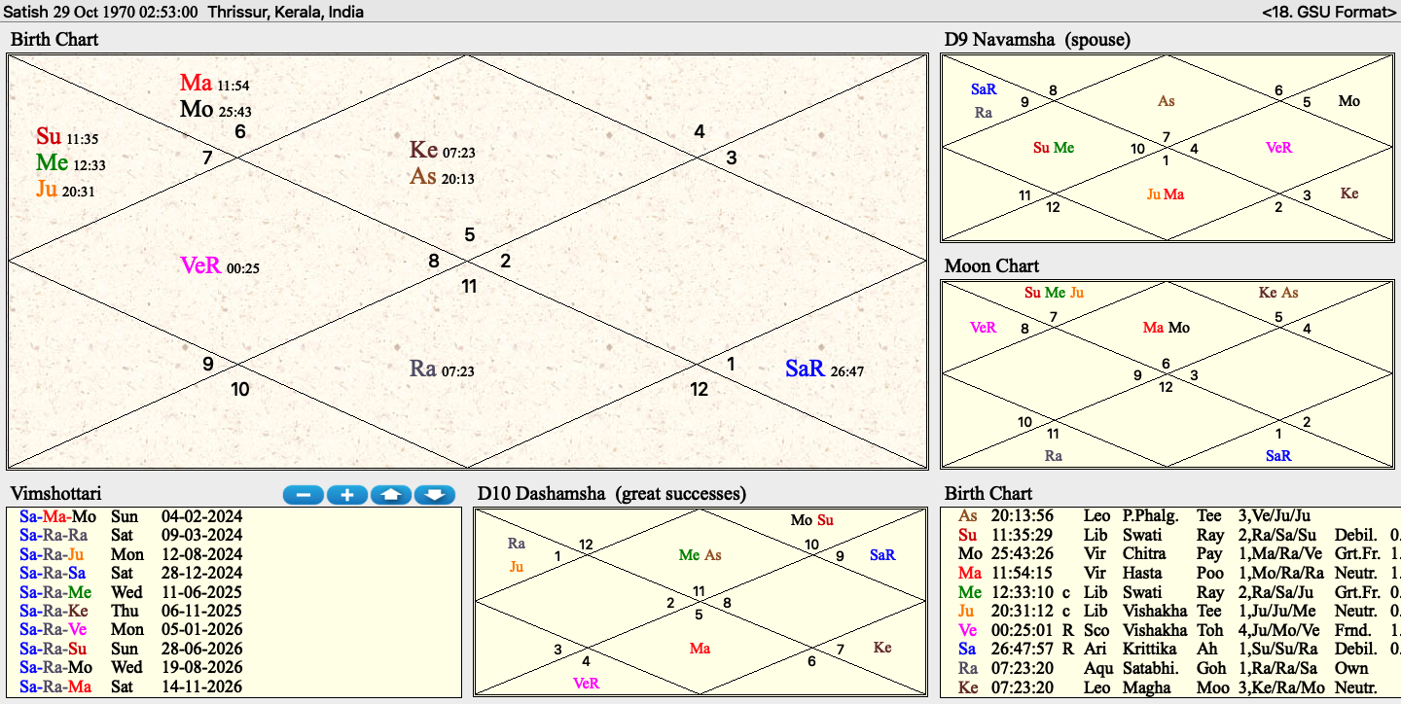

Next 12 Months
Your next 12 months are primarily divided into 4 phases, as explained below

Saturn-Mars-Moon: Now – 9 Mar 2024
General Trend : Solitude, Stress, Hurdles
What to expect :
- Moon active phase under Saturn major period
- Saturn is posited in 9th trine house and is debilitated
- Moon is posited in 2nd house with Mars
- This is the unfavorable phase for
- A phase marked with solitude and loneliness
- There will be certain level of void in your life
- You will face hurdles and obstacles in this period and things might not move the way you want
- You will feel a little unhappy and discontent too in this period
- This will also have negative impact on relationships as you will get a little distant from others
- The key to happiness I this phase is contentment

Saturn-Rahu-Rahu: 10 Mar 2024 – 12 Aug 2024
General Trend : Communication, career, financial life, financial gains
What to expect :
- Rahu active period under Saturn major period
- Rahu is very strong in your chart in its own sign Aquarius
- A period which will require lot of communication on your part
- Since this is Rahu dominated, your ambitions will be in limelight and lot of positivity is expected
- You will taste success and recognition too, but not up to your own high expectations
- A very important period from the perspective of your financial life too as you will take some key decisions in this period
- You will make good connection in this period, who will help you in long term
- Great period from the perspective of your financial life
- Expect sudden gains and speculative gains too
Saturn-Rahu-Jupiter: 13 Aug 2024 – 28 Dec 2024
General Trend : Success, recognition, career
What to expect :
- Best phase in next 12 months
- This is Jupiter active period
- Jupiter is highly favorable for you
- Jupiter is combust or weak in your chart
- Jupiter is posited in 3rd house with Sun and Mercury
- Great period from the point of view of success
- Career will align in this phase as you can expect recognition and glory, especially in public domain/ leadership which is pertinent to your query
- You will work hard and ensure that you attain all your goals
- Your personal life might take a backseat in this period and hence you should ensure a good work life balance

Saturn-Rahu-Saturn: 29 Dec 2024 – 11 Jun 2025
General Trend : Hurdles, delays, health issues
What to expect :
- Worst phase in next 12 months
- This is saturn active period
- Saturn is the weakest planet in your chart
- Saturn is posited in debilitated state in 9th trine house
- A phase wherein you can expect hurdles and obstacles
- Delays will become a norm in this small phase and you should have low expectations
- Health issues will also trouble you
- You should take good care of your health and take health issues seriously

General Advise – Next 12 Months
- Be more active in social media/public life in next 12 months from the perspective of your career and highly pertinent to your query
- Try and have a good work life balance in next 12 months
- Aug-Dec 2024 is a very good period and you should make the most of it by taking important decisions in this period. You will taste success in public domain too in this period.
- Avoid liquor (Saturn major period going on)
- Avoid ego clashes or other issues with authority / boss
- Take extreme care of your inner wellbeing. Join Yoga/Meditation or any form of fitness regime
- Be careful with your words / emails.
- Do not stress yourself unnecessarily, especially due to your super high ambitions
- Avoid procrastination though
- Wear more White cloths
- Listen to Shani Stotram
- Visit Shani temple every Saturday

Q&A

Qn2. my career prospects in public leadership
Ans:

- Good success is foreseen in public domain, but you should remember that Sun is debilitated in your chart and hence success will be always limited and not up to your expectations
- More success is seen after Jan 2027, but tillthen you will taste average success and not up to your high expectations
- Multi tasking is both your strength and weakness, in the sense that it allows you to do many things , but it also robs you of a focussed approach, so be careful while doing many things together
- Be more active on social media . yOu can start your youtube channel and interact more with mass in general
- You are also advised to have more focussed approach as you cannot do everything in hand. Choose wisely what you spend time on and only on high priority things in life.
- Do not waste time on unnecessary things in life / time wasting things
- Enhance your network / interpersonal relationships with others, especially people of influence
- Finance is one of your strongest area in chart and you will see significant gains next 12-24 months
- Avoid eating non vegetarian food next 12 months
- Here are the kind of projects you should focus on:
- Anything related to social media
- Mass communication
- Spirituality/healing
- Influencer marketing

Happy to help you Vedic way!
Team Tvam

